In-Class Activity: WordCount,
Count the number of occurrences of each word in a String using map() and reduce().
You can write this program with any programming language.
Example)
- Given input: “One a penny, two a penny, hot cross buns.”
- map() function read the input string and generate the output:
- (“One”, 1), (“a”, 1), (“penny”, 1),(“two”, 1), (“a”, 1), (“penny”, 1), (“hot”, 1), (“cross”, 1), (“buns”, 1).
- reduce() function reads output from map() function and generates output:
- (“One”, 1), (“a”, 2), (“penny”, 2), (“two”, 1), (“hot”, 1), (“cross”, 1), (“buns”, 1)

Code:
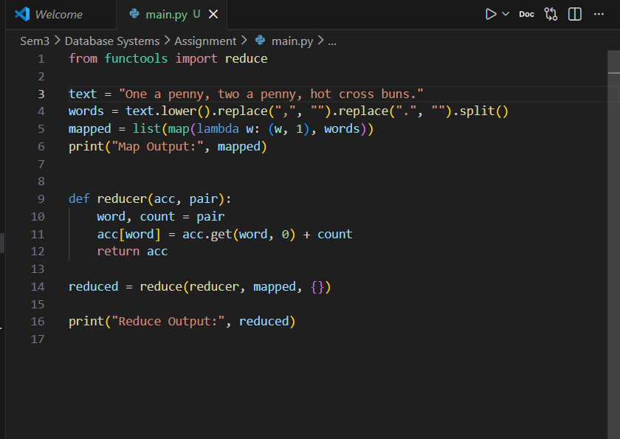

Step 1: map() → Convert input string into (word, 1) pairs
Step 2: reduce() → Combine counts of identical words
Output:
